Exercises with Lists – Unit 3.1
These exercises focus on the nuts and bolts of how lists work. Highlights:
- creating a list e.g. fruit = [“apple”, “orange”, “banana”, “pear”]
- Slices: e.g. fruit[2], fruit[1:3]

Create Python programs to do the following:
1. Make a list of five of your friends and a list of five emotions or action words (e.g. “loves”, “hates”, “misses” ....) For each friend in the list randomly choose a word and another friend in the list. Don't worry if “Jack loves Jack”, he probably does anyways. save as listEx1.py

2. Make a list of ten fruits and another list of the price each fruit. Use these two lists to create an attractive “fruit stand” menu. save as listEx2.py

3. I had my eight nieces and nephews over to my house in the summer to pick weeds, because I hate doing it myself. I paid each of them $12.50 but it bothered me that some of them gave it their all and some of them spent more time with the Super-Soakers than they did pulling weeds. I've decided that next summer I'm going to pay based on performance. I'm still going to pay $100 in total but this time how much each person gets will be based on how many weeds they pulled. Write a program to help me out. I need your program to let the user type in eight kids names and how many weeds each of the kids pulled then print out a list of how much each kid has earned. (the percentage of the $100 they get should be based on the percentage of the pile of weeds that they picked) save as listEx3.py
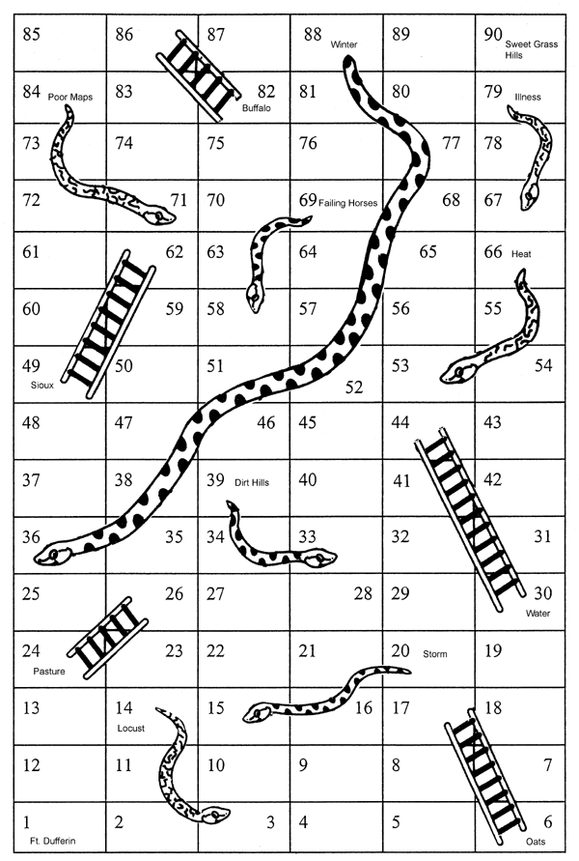
4. Snakes and Ladders can be a fun game for kids to play but you realize when you get older that the players actually have no choices at all. To illustrate just how little input the players have I want you to make a computer program that allows two players to play snakes and ladders on the board given.

The rules of the game are simple. On each player's turn they roll one six sided die and move ahead that many squares. If they end their move at the base of a ladder then they automatically climb to the top of the ladder. If they end their move at the end of a snake they automatically slide down to its head. To win the game you must be the first player to land on the last square. If you are near the end and your roll would cause you to go past the end square you don't move for that turn.

Your computerized version will look something like:
Player 1 hit enter to roll

You rolled: 3
You are at spot 3
Player 2 hit enter to roll

You rolled: 6
You climbed a ladder
You are at spot 17
although you can write this program without using lists, you should ask yourself how you can use lists to encode where the snakes and ladders are. save as listEx4.py

